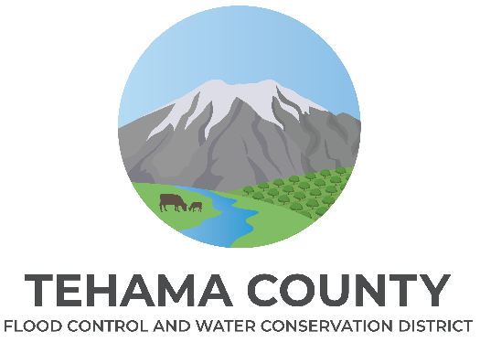

Groundwater Commission
Member Application

The Tehama County Flood Control and Water Conservation District formed an eleven-member Groundwater Commission comprised of city and water district representatives as well as local stakeholders. The Commission has advisory responsibilities pertaining to groundwater management in the subbasins or portions thereof for which the District has been designated as the Groundwater Sustainability Agency.
Agencies representing larger groundwater pumpers (City of Corning, City of Red Bluff, City of Tehama, El Camino Irrigation District, Los Molinos Community Services District, and Rio Alto Water District) in Tehama County will have an established seat on the Commission.
There shall be one representative to the Commission from each Supervisorial District. The County Board of Supervisors shall appoint the representatives upon recommendation from the respective Supervisor from each District. No two members should be officers, employees, or agents of the same agency, special district, or public or private corporation.
The Commission would benefit from representatives with the following:
- knowledge of SGMA
- knowledge of Tehama County Groundwater Sustainability Plans
- knowledge of local groundwater issues,
- commitment to cooperative solution development
- an interest in the preservation, protection, and enhancement of the groundwater in Tehama County.
Applications are being solicited for the following representatives:
Check which position you are applying for.

[ ] Supervisorial District 1 – Term Expires January 5, 2029

[ ] Supervisorial District 2 – Term Expires January 5, 2029

[ ] Supervisorial District 5 – Term Expires January 5, 2029

Applicant Name:
Applicant Phone Number:
Applicant Address:
Applicant Email Address:

Describe your interest, any technical expertise in a water-related field, knowledge of the Tehama County groundwater sustainability plan and requirements mandated by the Sustainable Groundwater Management Act, knowledge of the groundwater-dependent ecosystems, climatology, and the local social/economic issues related to sustainable groundwater.

Explain your interest in sustainable groundwater and your presumptive use of groundwater in Tehama County.

Applicant’s Signature: Date:

Please submit the Application for Appointment to the Tehama County Groundwater Commission to Tehama County Flood Control and Water Conservation District (1509 Schwab St., Red Bluff, CA 96080) or via email to Justin Jenson at jjenson@tcpw.ca.gov no later than 4 PM on January 17, 2025.

Questions regarding the Groundwater Commission or application process can be directed to Justin Jenson at jjenson@tcpw.ca.gov or (530) 690-0700.

***Commission members will be required to complete a Statement of Economic Interests – Form 700***

